第二篇阅读课教学
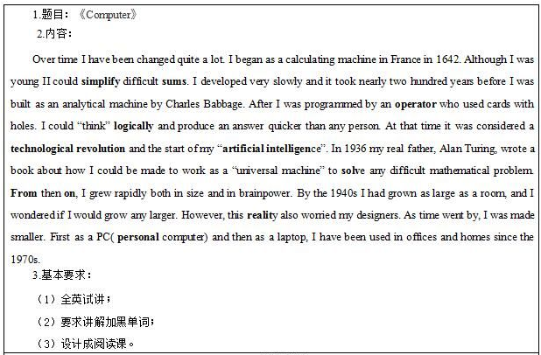

试讲稿
T: Good morning,boys and girls.
S:Good morning,teacher.
T: Do you like riddles？
S: Yes,we do.
T: Ok, let's make riddles, listen carefully, please. I can be used for calculating. Besides, I can also be used for watching DVD, sending e-mail and communicating through the Internet. People think I am useful and helpful. Do you know who I am?
S: Computer.
T: Great! Computer is one of the greatest invention in human’shistory.As we know,
science and technology is developing very fast and computers have become smaller
andsmaller. They have been used in many fields. Do you know want to know how it developed ?
S: Yes.
T: Ok, today we’ll do a reading about computer.
T: Now, boys and girls,have a look at the title of this passage and guess what it talks about.
S1: Maybe it talks about the advantage of computer.
T: Good. Any others?
S2: It maybe about the development of computers.
T: Great. Ok, Boys and girls, read this passage quickly and make sure the main idea of this passage.Let’s go! Have you finished?
S: Yes, I have.
T: Well, we can know this passage talks about the development and use of computer. Who is the speaker-”I” in this passage?
S: Computer.
T: Right. Now, boys and girls, read this passage again, and identifytrue or false on the screen.
Are you clear?
S: Yes.
T: Ok, the first one（point to the screen）,true or false?
S1: False.
T: Why?
S1: He began as a calculating in France in 1642, not in 1936.
T: Good job! The second one, true or false?
S: True.
T: Good.The last one, true or false?
S: False.
T: Why?
S2: As time went by, he was made smaller,not bigger.
T: Excellent!All of you did a good job. Now read this passage carefully, and think about these questions.Question1:What can I do when I was young? Question2:When was the computer the biggest? Question3:Why did my designer become worried in 1940s? Understand?
S: Yes.
T: Ok, let’s start.Well, who wants to share your opinion?Question1?
S1: I could simplify difficult sums when I was young.
T: Great.And question2?
S2: In the 1940s.
T: Well done. The last one？
S3: Because he was worried if the computer would grow any larger.
T: Do you agree with her?
S: Yes.
T: Wonderful! Now, boys and girls, look at this passage, try your best to find out the meanings of words in bold, you can discuss with your partner or look up the dictionary, OK? Go! Time’s up,who wants to show your answer?
S1: Simplify means to make something easier or less complicated; sums means arithmetic problem.
T: Very good. Go on.
S2: Operator means who used cards with holes; logically means according to logical reasoning.
T: Good job! Next
S3: Technological revolution means the transformation from an agricultural to an industrial nation;artificial intelligence means the study of how to make computers do intelligent things that people can do, such as think and make decisions.
T: Well done!The last three words.
S4: From then on means from that time onwards; reality means the state of being actual or real; personal means concerning or affecting a particular person or his or her private life and personality.
T: Brilliant!Now work in groups,each group will retell this passage in your words,understand?
Ss:Yes.
T: Let’s start.Ok,stophere,which group wants to retell? Right, group3,please.
T:How about their narrative?
S: Wonderful！
T: I think so. Ok,boys and girls,what above is our new lesson,who wants to make a summary?
S1: This class we learned the development and use of computer.
S2: We also learned the skill of reading and some new words.
T: Your summary are comprehensive.Homework time, after class,make a timeline about the development of computer and imagine the future trend of computer, we’ll have a discussion next class.
Ok, today’s class is over, see you!

